FoodConnect- To supply left over food to poors



**Project Overview**

Food Connect is a Salesforce-based platform designed to efficiently collect and distribute leftover food from donors (restaurants, events, households) to underprivileged communities in need. The platform leverages Salesforce’s powerful CRM tools to manage donors, track food availability, and coordinate logistics for food delivery. It automates various workflows to ensure timely communication and efficient supply chain management.

## Table of Contents

1. **Introduction**
2. **Project Objectives**
3. **Key Features**
4. **Salesforce Developer Setup**
5. **System Architecture**
6. **Screenshorts of Output**
7. **Vedio Demonstation**
8. **Conclusion**

## Introduction

Food Connect is built to address food waste while helping people in need. The project uses Salesforce as a backbone for its donor management, food inventory tracking, and delivery coordination. By incorporating the full power of Salesforce’s CRM, automation, and analytics capabilities, this platform enables seamless collaboration between food donors, volunteers, and distribution networks

## Project Objectives

* + **Distribute leftover food** efficiently to charities and shelters.
  + **Automate workflows** for notifications, pickups, and deliveries.
  + **Track inventory and supply chain** in real-time.
  + **Improve community outreach** and reporting.

## Key Features

* + **Food Pickup and Distribution Tracking:** Automate requests for food pickup and ensure delivery to shelters.
  + **Inventory Management:** Monitor food availability in real-time, ensuring efficient allocation based on demand.
  + **Reporting and Analytics:** Create reports and dashboards on food distribution, donor contributions, and recipients.
  + **Mobile Access:** Allow volunteers and coordinators to access the platform on mobile devices using Salesforce Mobile.

1. **Salesforce Developer Setup And WorkFlow**

# Creating Developer Account

Creating a developer org in salesforce.

* 1. Go to <https://developer.salesforce.com/signup>
  2. 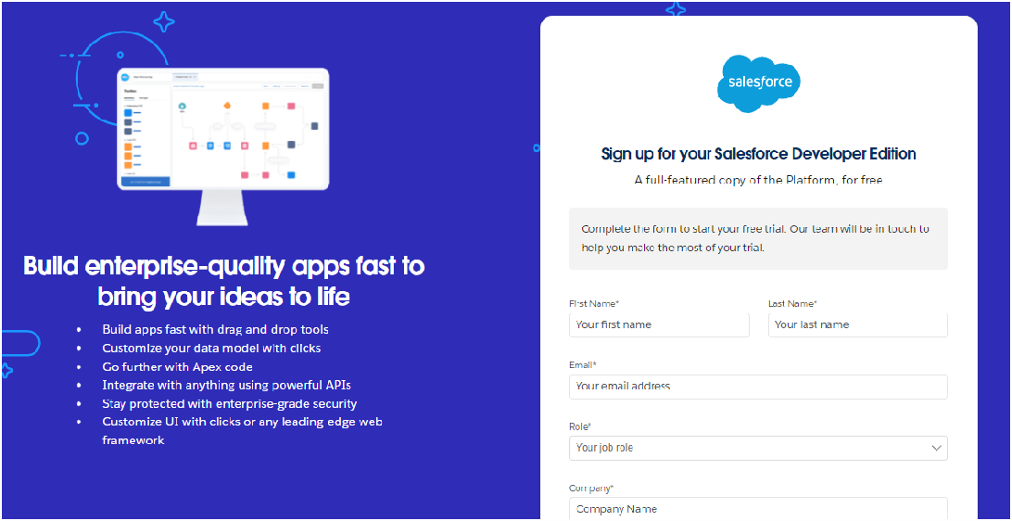On the sign up form, enter the following details :
     1. First name & Last name
     2. Email
     3. Role : Developer
     4. Company : College or Company Name
     5. County : India
     6. Postal Code : pin code
     7. Username : should be a combination of your name and company

1. **System Architecture**

# Account Activation

* 1. 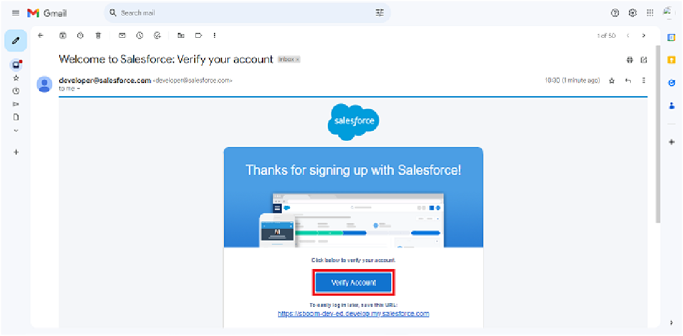Go to the inbox of the email that you used while signing up. Click on the verify account to activate your account. The email may take 5-10mins.

1. 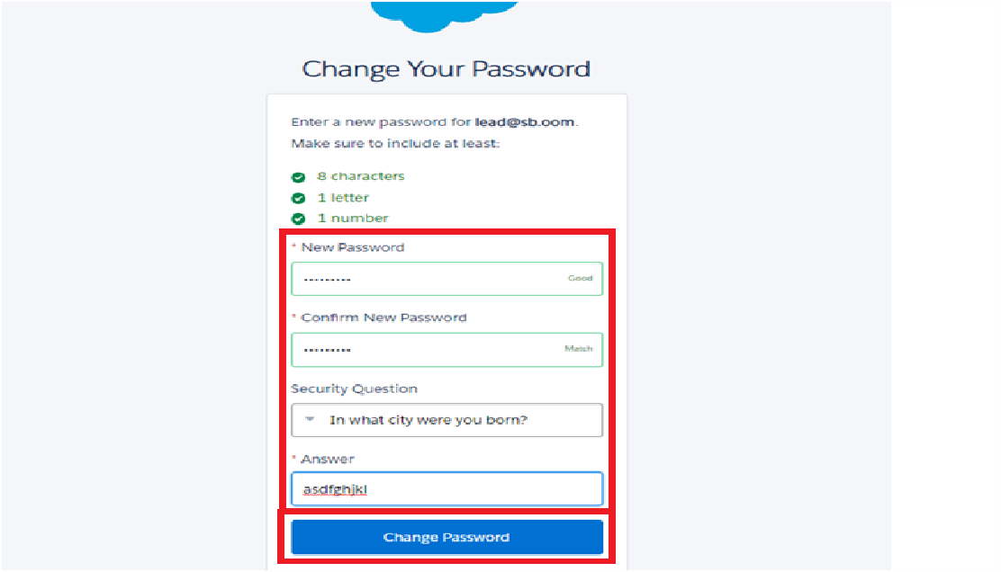

Click on Verify Account

1. Give a password and answer a security question and click on change password.
2. Give a password and answer a security question and click on change password.
3. Then you will redirect to your salesforce setup page.

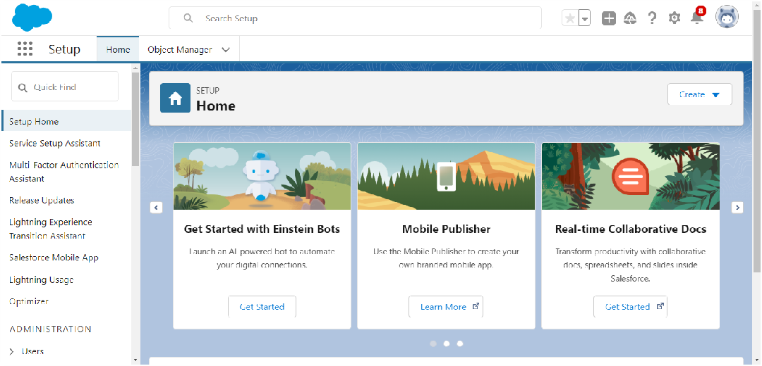

# Createing Objects

To Navigate to Setup page:

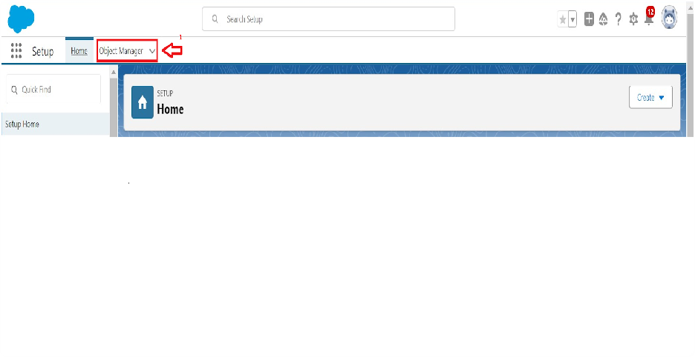

To create an object:

* 1. 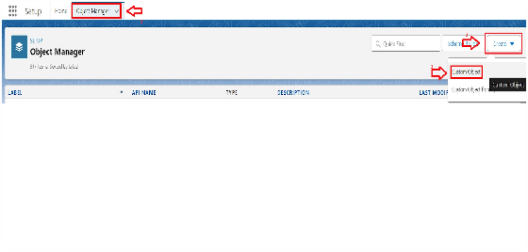From the setup page > Click on Object Manager > Click on Create > Click on Custom Object.
  2. On Custom object defining page:
  3. Enter the label name, plural label name, click on Allow reports, Allow search.

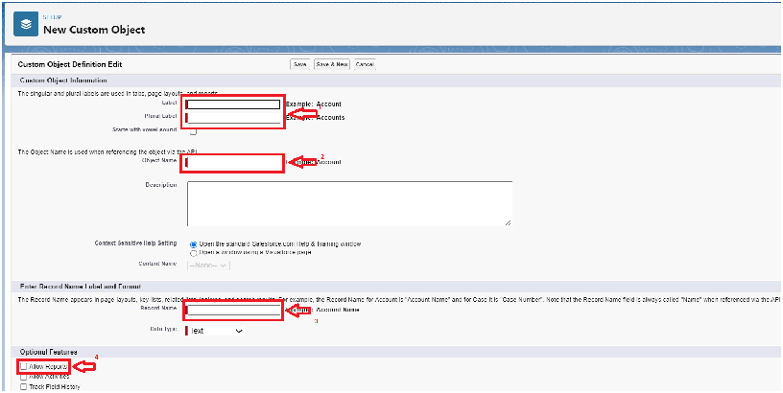

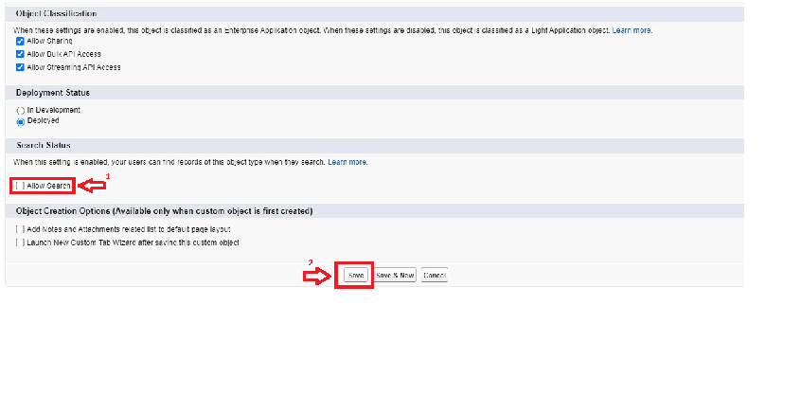

* 1. Click on Save.

here we create 4 ojects in the projects that venue obejct, drop-off point object,

task object, volenteer object, execution details object.As the same way as above mention in the secrenshorts you have to follow the same process for every object that you made.

# Creating a Custom Tab

To create a Tab:(Venue)

* 1. Go to setup page >> type Tabs in Quick Find bar >> click on tabs >> New (under custom object tab)

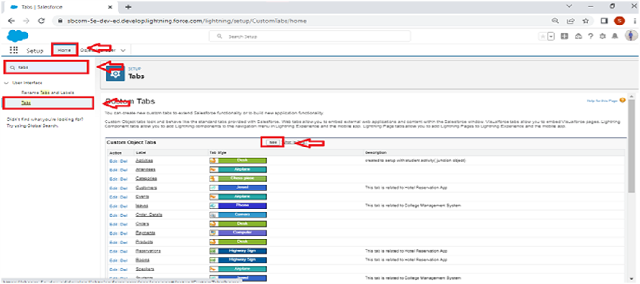

1. Select Object(Venue) >> Select the tab style >> Next (Add to profiles page) keep it as default >> Next (Add to Custom App) uncheck the include tab .
2. Make sure that the Append tab to users' existing personal customizations is checked.
3. Click save

# Create a Lightning App

### To create a lightning app page:

* 1. Go to setup page >> search “app manager” in quick find >> select “app manager”

>> click on New lightning App.

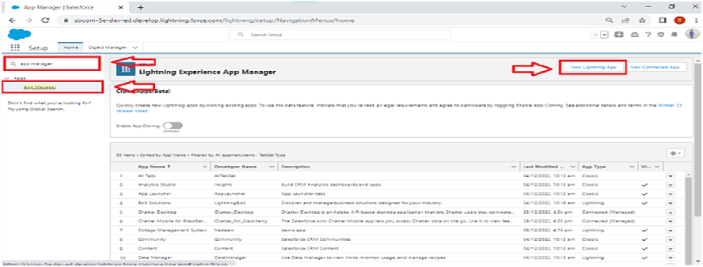

* 1. Fill the app name in app details and branding as follow App Name : FoodConnect

Developer Name : This will auto populated

Image : optional (if you want to give any image you can otherwise not mandatory) Primary color hex value : keep this default.

* 1. Then click Next >> (App option page)Set Navigation Style as Standard Navigation

>> Next.

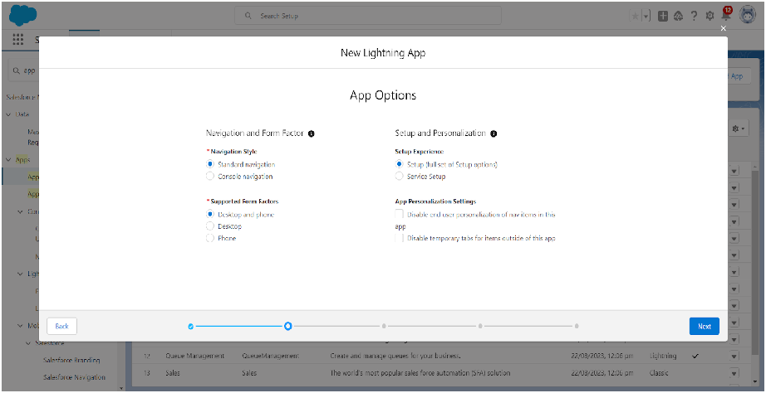

* 1. (Utility Items) keep it as default >> Next.
  2. To Add Navigation Items:

Search for the item in the (Home, Venue, Drop-Off Point, Task, Volunteer, Execution Details, Reports) from the search bar and move it using the arrow button >> Next

>> Next.

* 1. To Add User Profiles:

Search profiles (System administrator) in the search bar >> click on the arrow button >> save & finish.

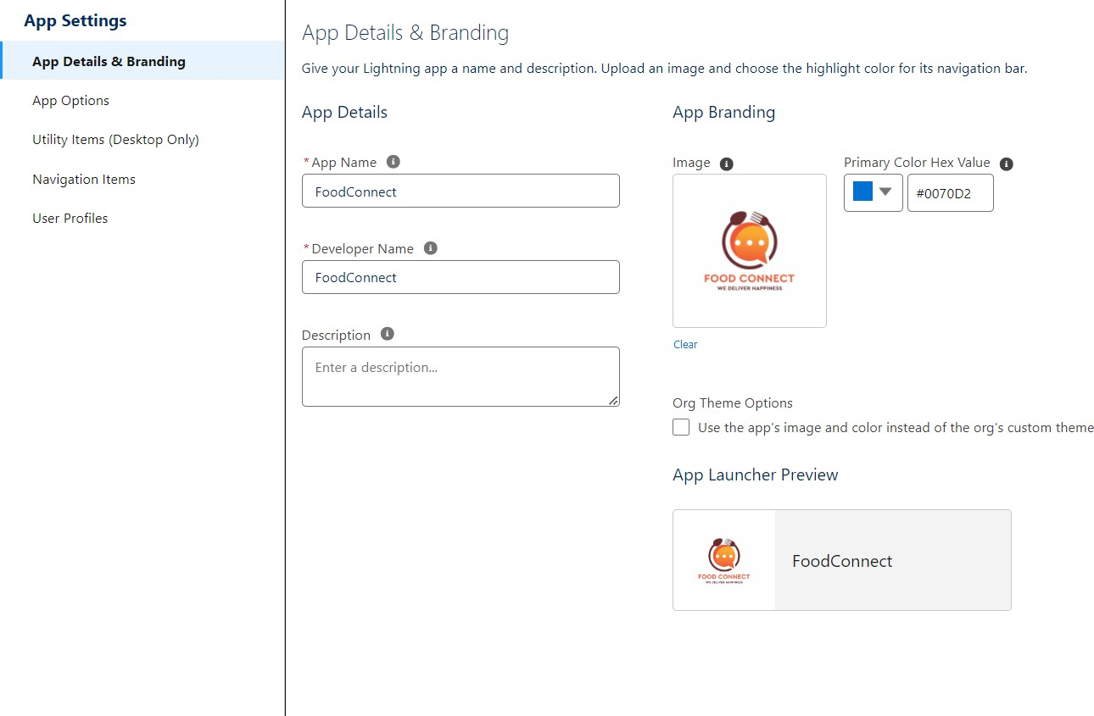**Here I am adding my output of creating lighting app**

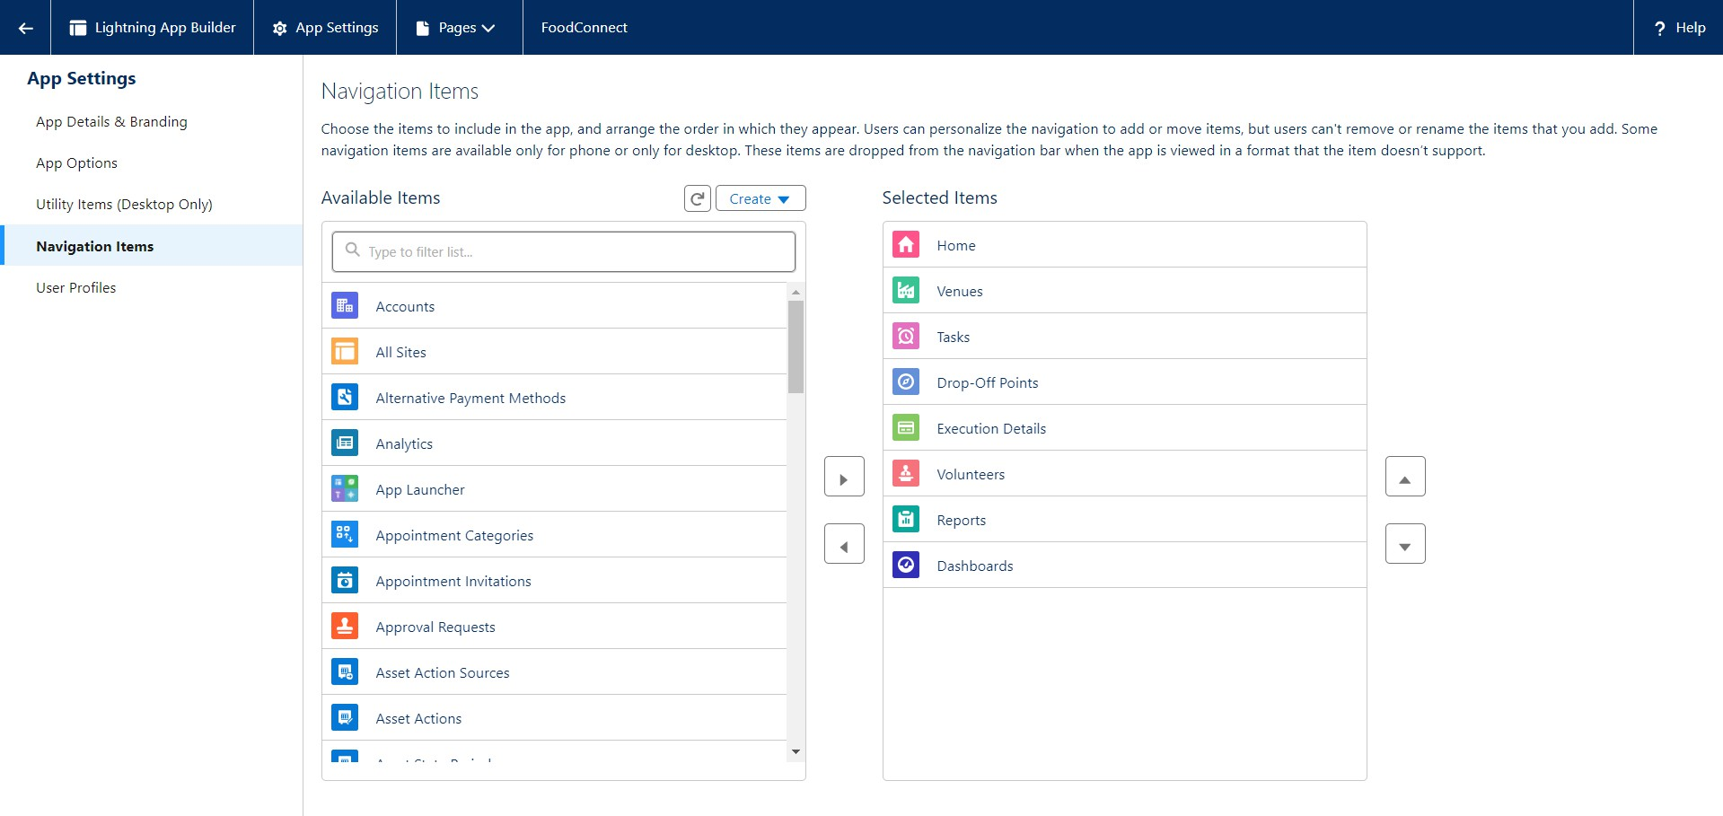

# Creation of Relationship fields in objects

### Creation of Lookup Relationship Field on Volunteer Object :

* 1. Go to setup >> click on Object Manager >> type object name(Volunteer) in the search bar >> click on the object.

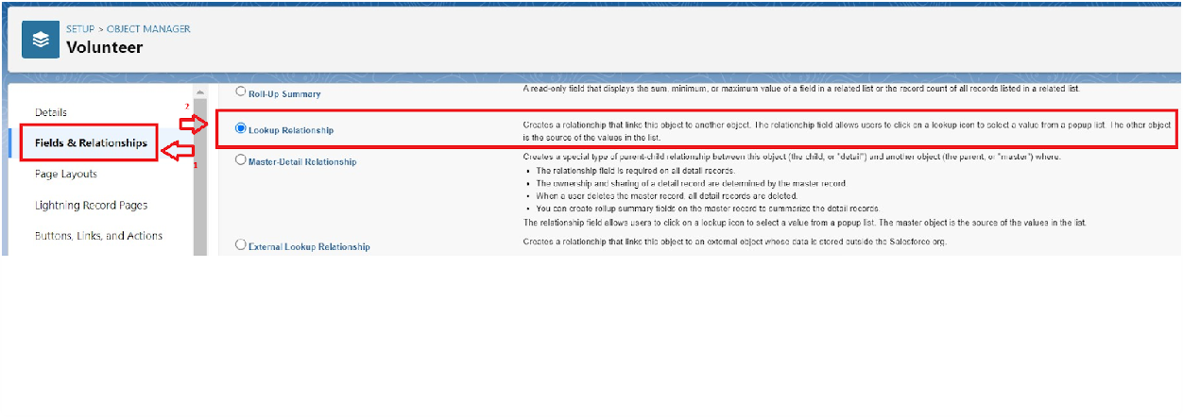

* 1. Now click on “Fields & Relationships” >> New
  2. Select Master Detail relationship
  3. Select the related object “Drop-Off point” and click next.

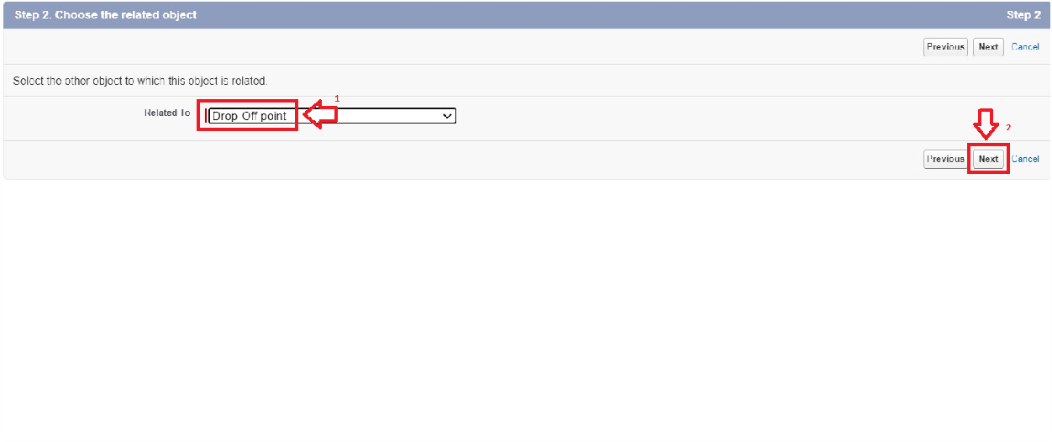

* 1. Field Name : Drop_Off_point
  2. Field label : Auto generated
  3. Next >> Next >> Save.

just like that I crated all the realtionship as the same way it littel bit diffreernt in the moden realtionship and the lookup realtionship feilds.

# Creation of fields for the Venue object

1. Go to setup>> click on Object Manager >> type object name(Venue) in search bar

>> click on the object.

1. Now click on “Fields & Relationships” >> New
2. Select Data type as a “Email” and Click on Next
3. Fill the Above as following:
   * Field Label : Contact Email
   * Field Name : Contact Email
   * Click on required check box
   * Click on Next >> Next >> Save and new.

### To create another fields in an object:

1. Go to setup >> click on Object Manager >> type object name(Venue) in search bar

>> click on the object.

1. Now click on “Fields & Relationships” >> New
2. Select Data type as a “Phone” and Click on Next
3. Fill the Above as following:
   * Field Label : Contact Phone
   * Field Name : Contact Phone
   * Click on required check box
   * Click on Next >> Next >> Save and new.

### To create another fields in an object:

1. Go to setup >> click on Object Manager >> type object name(Venue) in search bar

>>click on the object.

1. Now click on “Fields & Relationships” >> New
2. Select Data type as a “Geolocation” and Click on Next
3. Fill the Above as following:
   * Field Label : Location
   * Decimal Places : 4
   * Field Name : Location
   * Description : Enter the Geolocation of your Venue
   * Click on Next >> Next >> Save and new.

To create another fields in an object:

1. Go to setup >> click on Object Manager >> type object name(Venue) in search bar

>> click on the object.

1. Now click on “Fields & Relationships” >> New
2. Select Data type as a “Long Text Area” and Click on Next
3. Fill the Above as following:
   * Field Label : Venue Location
   * Field Name : Venue_Location
   * Click on Next >> Next >> Save and new.

# Creation of fields for the Drop-Off point object

Go to setup >> click on Object Manager >> type object name(Drop-Off point) in search bar

>> click on the object.

1. Now click on “Fields & Relationships” >> New
2. Select Data type as a “Geolocation” and Click on Next
3. Fill the Above as following:
   * Field Label : Location 2
   * Field Name : gets auto generated
   * Description : Enter the Geolocation of the Drop off Point
   * Geolocation Options : select Decimal
   * Decimal Places : 4
   * Click on Next >> Next >> Save and new.

To create another fields in an object:

1. Go to setup >> click on Object Manager >> type object name(Drop-Off point) in search bar >> click on the object.
2. Now click on “Fields & Relationships” >> New
3. Select Data type as a “Formula” and Click on Next
4. Fill the Above as following:
   * Field Label : distance calculation
   * Field Name : distance_calculation
   * Formula Return Type : Number
   * Formula Options : DISTANCE( Location_2 c , Venue r.Location c , 'km')
   * Click on Next >> Next >> Save and new.

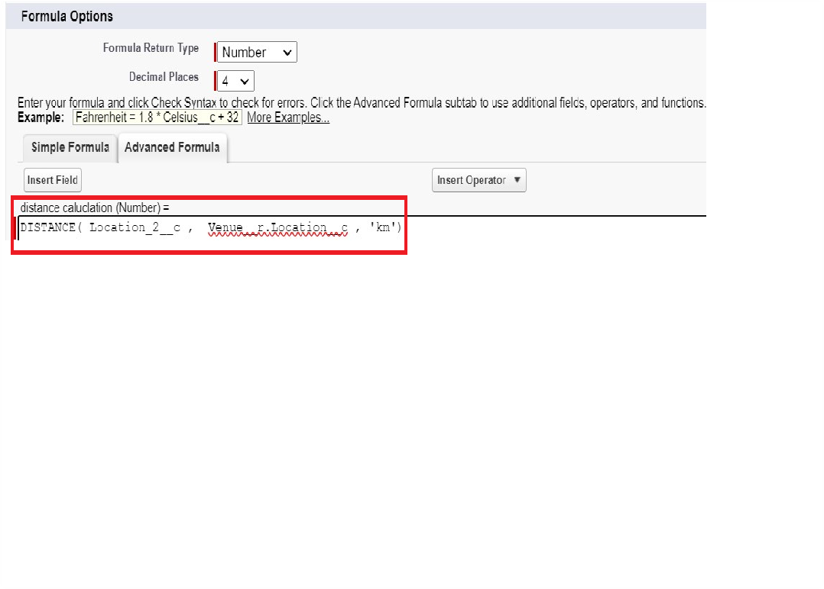

To create another fields in an object:

1. Go to setup >> click on Object Manager >> type object name(Drop-Off point) in search bar >> click on the object.
2. Now click on “Fields & Relationships” >> New
3. Select Data type as a “Picklist” and Click on Next
4. Fill the Above as following:
   * Field Label : State
   * Field Name : State
   * Enter values, with each value separated by a new line : Andhra Pradesh

Arunachal Pradesh Assam

Bihar Chhattisgarh Goa

Gujarat Haryana

Himachal Pradesh Jharkhand Karnataka

Kerala Maharashtra Madhya Pradesh Manipur Meghalaya Mizoram Nagaland Odisha

Punjab

Rajasthan Sikkim Tamil Nadu Tripura Telangana

Uttar Pradesh Uttarakhand West Bengal

Andaman & Nicobar (UT)

Chandigarh (UT)

Dadra & Nagar Haveli and Daman & Diu (UT) Delhi [National Capital Territory (NCT)] Jammu & Kashmir (UT)

Ladakh (UT) Lakshadweep (UT) Puducherry (UT)

* + Click on required check box
  + Click on Next >> Next >> Save and new.

To create another fields in an object:

1. Go to setup >> click on Object Manager >> type object name(Task) in search bar >> click on the object.
2. Now click on “Fields & Relationships” >> New
3. Select Data type as a “Number” and Click on Next
4. Fill the Above as following:
   * Field Label : Distance
   * Field Name : Distance
   * Length : 14
   * Decimal Places : 4
   * Click on required check box
   * Click on Next >> Next >> Save and new.

# Creation of fields for the Task object

Go to setup>> click on Object Manager >> type object name(Task) in search bar >> click on the object.

1. Now click on “Fields & Relationships” >> New
2. Select Data type as a “Auto Number” and Click on Next
3. Fill the Above as following:
   * Field Label : Task ID
   * Display Format : TASK-{0}
   * Starting Number : 1
   * Field Name : gets auto generated
   * Click on required check box
   * Click on Next >> Next >> Save and new.

To create another fields in an object:

1. Go to setup >> click on Object Manager >> type object name(Task) in search bar >> click on the object.
2. Now click on “Fields & Relationships” >> New
3. Select Data type as a “Date” and Click on Next
4. Fill the Above as following:
   * Field Label : Date
   * Field Name : Date
   * Click on required check box
   * Click on Next >> Next >> Save and new.

To create another fields in an object:

1. Go to setup >> click on Object Manager >> type object name(Task) in search bar >> click on the object.
2. Now click on “Fields & Relationships” >> New
3. Select Data type as a “Picklist (Multi-Select)” and Click on Next
4. Fill the Above as following:
   * Field Label : Food Category
   * Field Name : Food Category
   * Enter values, with each value separated by a new line : Veg

Non-Veg

Salad Snack

* + Click on required check box
  + Click on Next >> Next >> Save and new.

To create another fields in an object:

1. Go to setup >> click on Object Manager >> type object name(Task) in search bar >> click on the object.
2. Now click on “Fields & Relationships” >> New
3. Select Data type as a “Number” and Click on Next
4. Fill the Above as following:
   * Field Label : Number of People Served
   * Field Name : Number_of_People_Served
   * Click on required check box
   * Click on Next >> Next >> Save and new.

To create another fields in an object:

1. Go to setup >> click on Object Manager >> type object name(Task) in search bar >> click on the object.
2. Now click on “Fields & Relationships” >> New
3. Select Data type as a “Text” and Click on Next
4. Fill the Above as following:
   * Field Label : Name of the Person
   * Field Name : Name_of_the_Person
   * Click on Next >> Next >> Save and new.

To create another fields in an object:

1. Go to setup>> click on Object Manager >> type object name(Task) in search bar >> click on the object.
2. Now click on “Fields & Relationships” >> New
3. Select Data type as a “Phone” and Click on Next
4. Fill the Above as following:
   * Field Label : Phone
   * Field Name : Phone
   * Click on Next >> Next>> Save and new.

To create another fields in an object:

1. Go to setup >> click on Object Manager >> type object name(Task) in search bar >>

click on the object.

1. Now click on “Fields & Relationships” >> New
2. Select Data type as a “Pick List” and Click on Next
3. Fill the Above as following:
   * Field Label : Rating
   * Field Name : Rating
   * Enter values, with each value separated by a new line : 1

2

3

4

5

* + Click on Next >> Next >> Save and new.

To create another fields in an object:

1. Go to setup >> click on Object Manager >> type object name(Task) in search bar >> click on the object.
2. Now click on “Fields & Relationships” >> New
3. Select Data type as a “Long Text Area” and Click on Next
4. Fill the Above as following:
   * Field Label : Feedback
   * Field Name : Feedback
   * Click on Next >> Next >> Save and

# Creation of fields for the Volunteer object

1. Go to setup >> click on Object Manager >> type object name(Volunteer) in search bar >> click on the object.
2. Now click on “Fields & Relationships” >> New
3. Select Data type as a “Auto Number” and Click on Next
4. Fill the Above as following:
   * Field Label : Volunteer ID
   * Field Name : gets auto generated
   * Click on required check box
   * Click on Next >> Next >> Save and new.
   * Click on Next >> Next >> Save and new.

To create another fields in an object:

1. Go to setup >> click on Object Manager >> type object name(Volunteer) in search bar >> click on the object.
2. Now click on “Fields & Relationships” >> New
3. Select Data type as a “Picklist” and Click on Next
4. Fill the Above as following:
   * Field Label : Gender
   * Field Name : Gender
   * Enter values, with each value separated by a new line : Female

Male

* + Click on Next >> Next >> Save and new.

To create another fields in an object:

1. Go to setup >> click on Object Manager >> type object name(Volunteer) in search bar >> click on the object.
2. Now click on “Fields & Relationships” >> New
3. Select Data type as a “Date” and Click on Next
4. Fill the Above as following:
   * Field Label : Available On
   * Field Name : Available On
   * Click on required check box
   * Click on Next >> Next >> Save and new.

To create another fields in an object:

1. Go to setup >> click on Object Manager >> type object name(Volunteer) in search bar >> click on the object.
2. Now click on “Fields & Relationships” >> New
3. Select Data type as a “Number” and Click on Next
4. Fill the Above as following:
   * Field Label : Age
   * Field Name : Age
   * Click on required check box
   * Click on Next >> Next>> Save and new.

To create another fields in an object:

1. Go to setup >> click on Object Manager >> type object name(Volunteer) in search bar >> click on the object.
2. Now click on “Fields & Relationships” >> New
3. Select Data type as a “Email” and Click on Next
4. Fill the Above as following:
   * Field Label : Email
   * Field Name : Email
   * Click on required check box
   * Click on Next>> Next >> Save and new.

To create another fields in an object:

1. Go to setup >> click on Object Manager >> type object name(Volunteer) in search bar >> click on the object.
2. Now click on “Fields & Relationships” >> New
3. Select Data type as a “Number” and Click on Next
4. Fill the Above as following:
   * Field Label : Contact Number
   * Field Name : Contact_Number
   * Click on required check box
   * Click on Next >> Next >> Save and new.

To create another fields in an object:

1. Go to setup >> click on Object Manager >> type object name(Volunteer) in search bar >> click on the object.
2. Now click on “Fields & Relationships” >> New
3. Select Data type as a “Text Area (Long)” and Click on Next
4. Fill the Above as following:
   * Field Label : Address
   * Field Name : Address
   * Click on Next >> Next >> Save and new.

To create another fields in an object:

1. Go to setup >> click on Object Manager >> type object name(Volunteer) in search bar >> click on the object.
2. Now click on “Fields & Relationships” >> New
3. Select Data type as a “Date” and Click on Next
4. Fill the Above as following:
   * Field Label : Date of Birth
   * Field Name : Date_of_Birth
   * Click on Next >> Next >> Save and new.

# Creation of fields for the Execution Details object

1. Go to setup >> click on Object Manager >> type object name(Volunteer) in search bar >> click on the object.
2. Now click on “Fields & Relationships” >> New
3. Select Data type as a “Auto Number” and Click on Next
4. Fill the Above as following:
   * Field Label : Execution ID
   * Field Name : gets auto generated
   * Click on required check box
   * Click on Next >> Next >> Save and new.

# Create Flow to create a record in Venue object

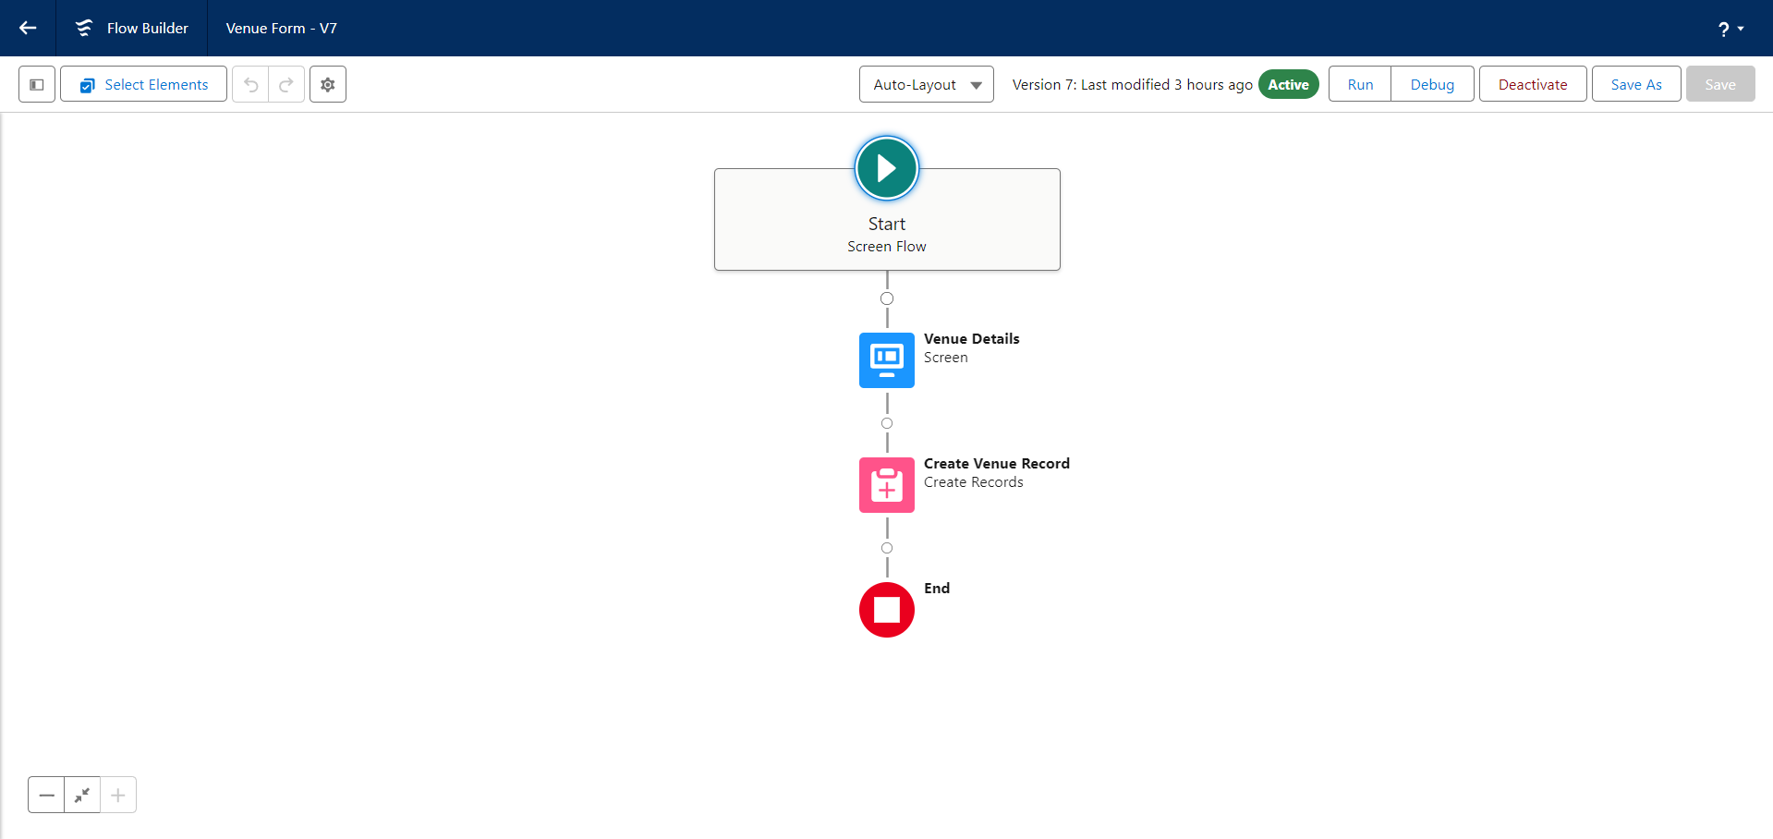the flow should look like this----

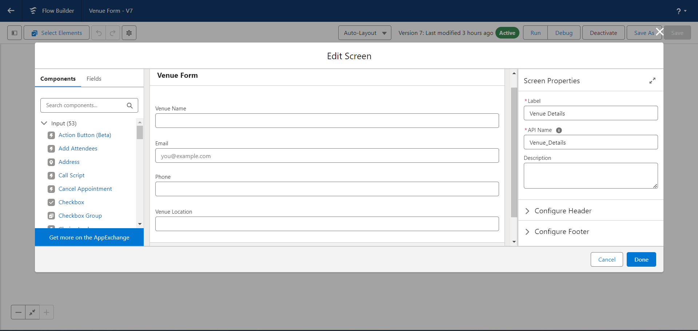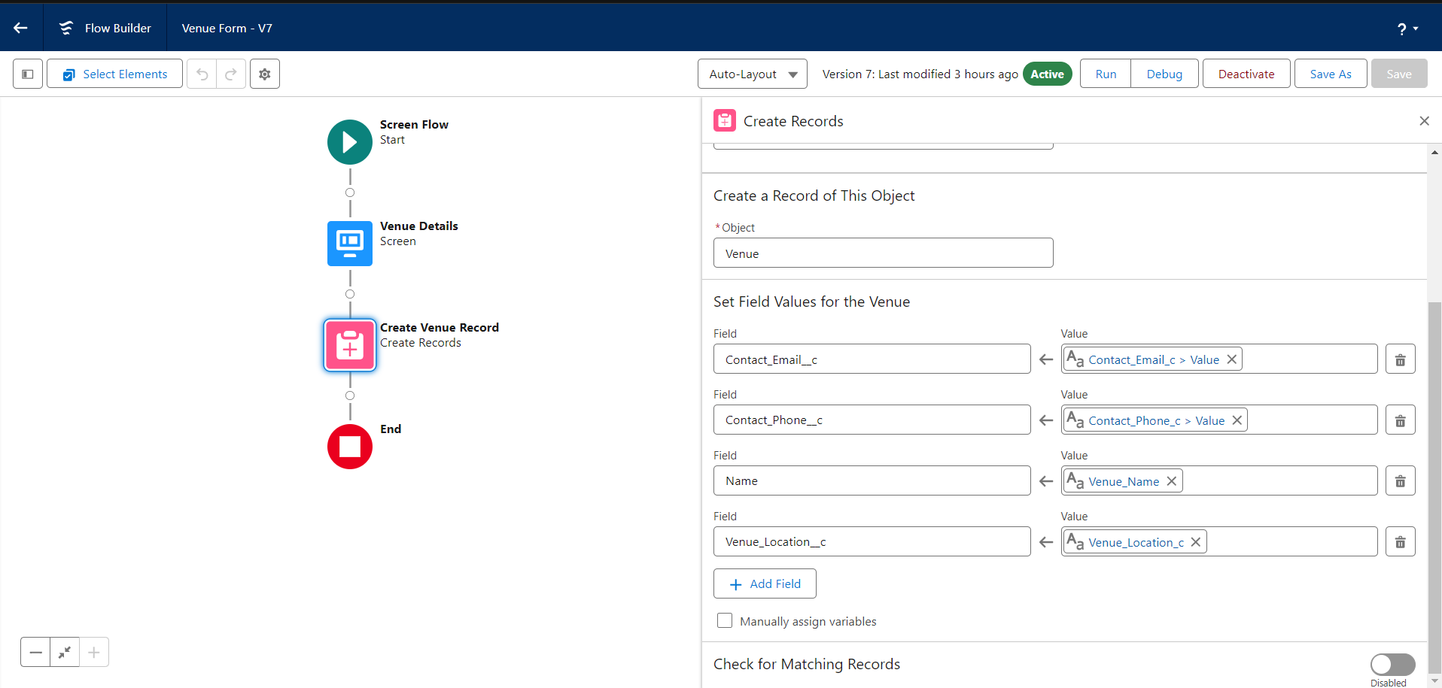

# Create a Trigger

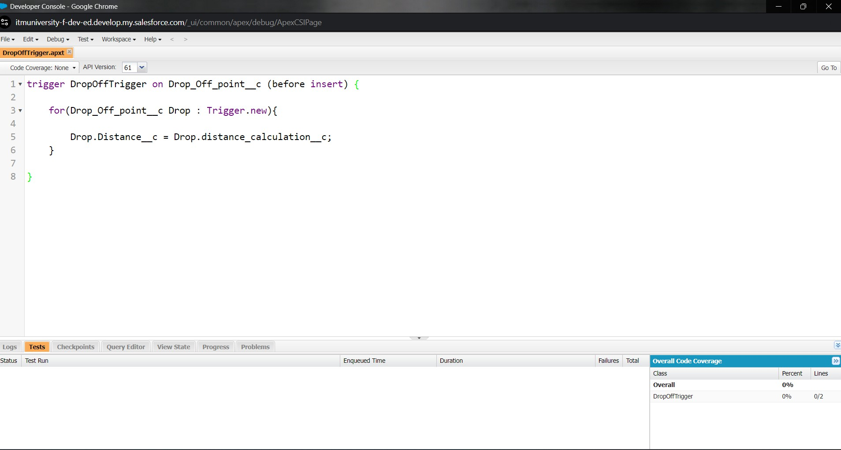

the code should look like this the trriger has created.

# Creation of Users and profile

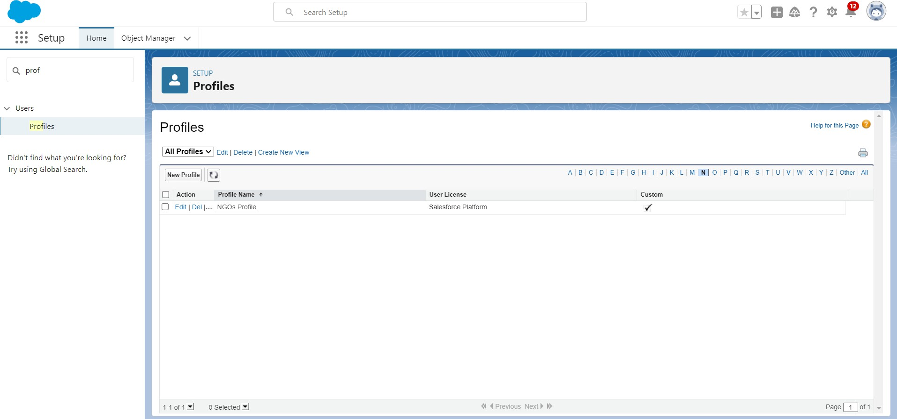here we have to crate a NGOs profile and under this profile we have to cretae a users that are going to be the NGOs foundations

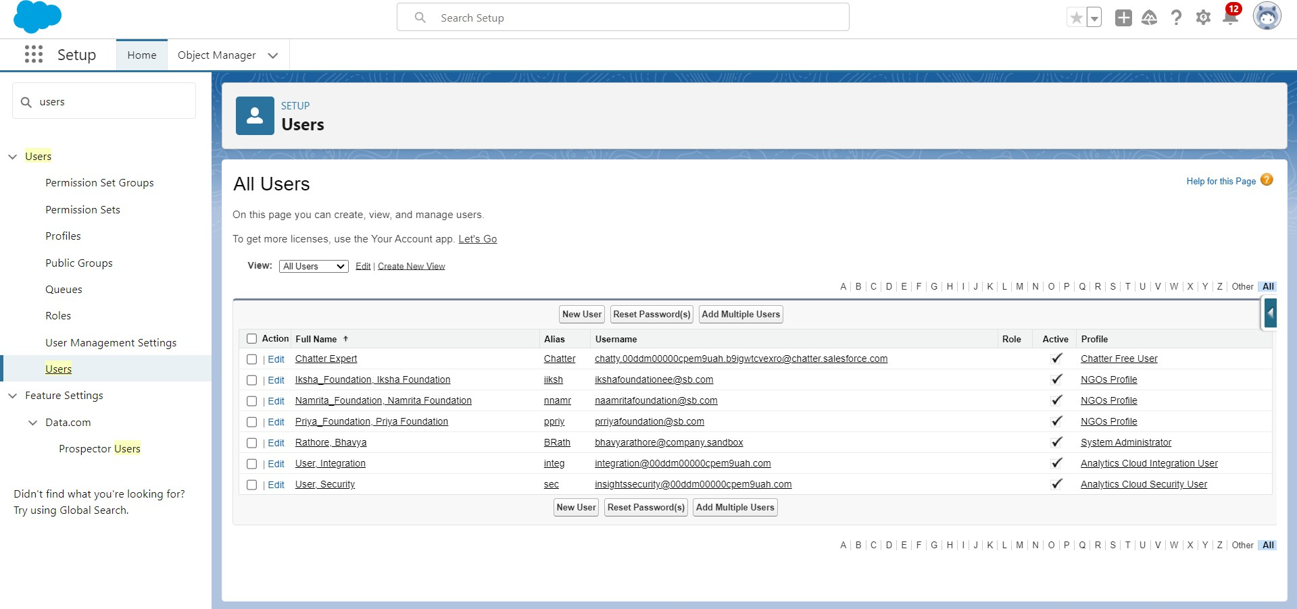

here I created a three foundation of my own. ishika foundations

priya foundations namrita foundations

1. Creation of Public Group 1,2,3

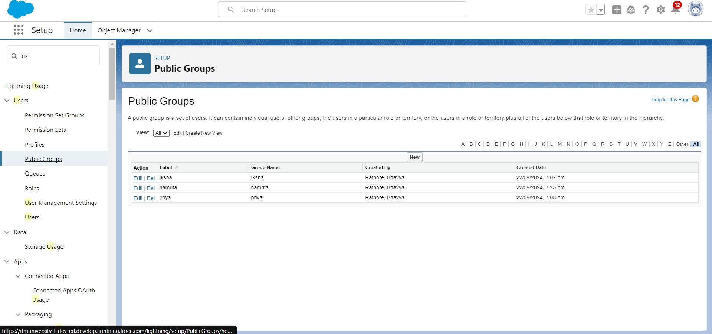

Creation of Report on Venue with DropOff with Volunteer

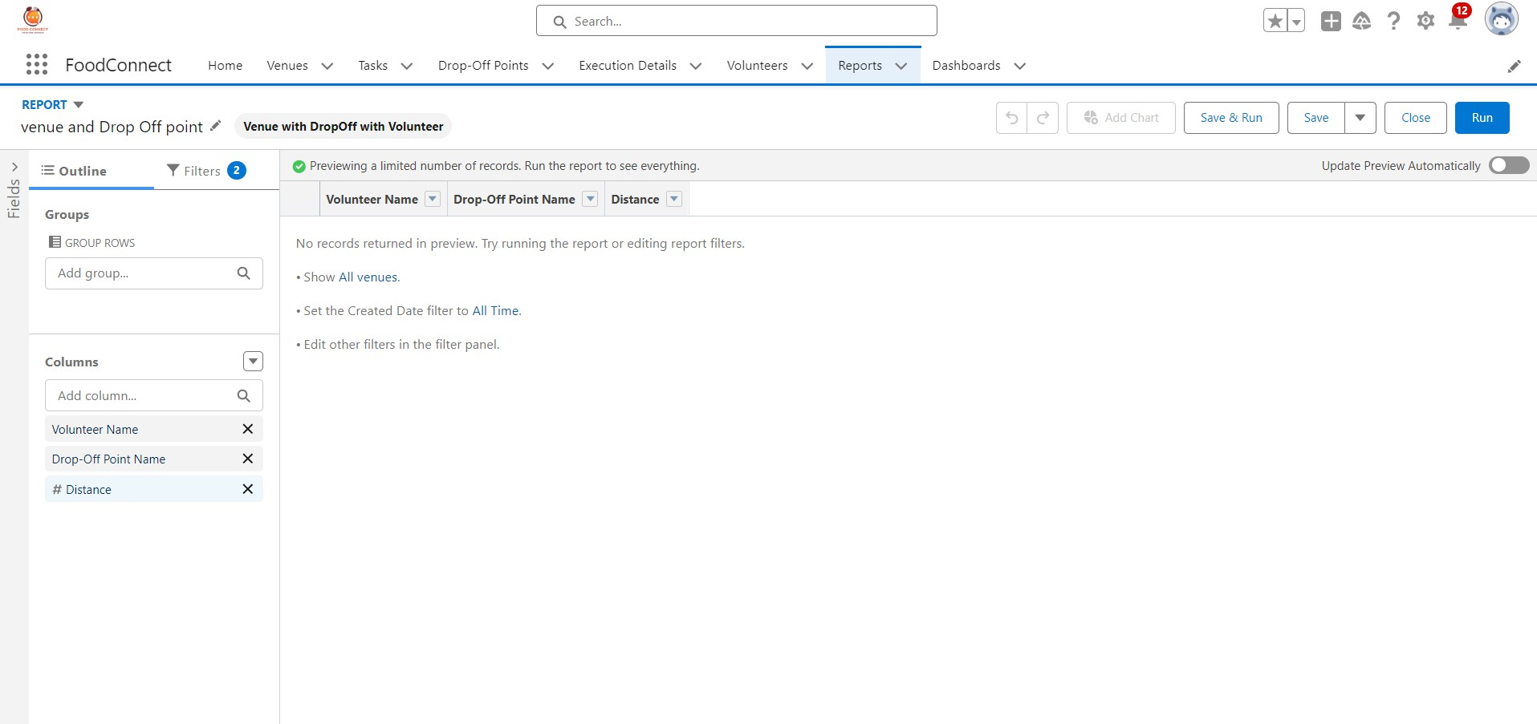

Creation of Report on Volunteers with Execution Details and Tasks

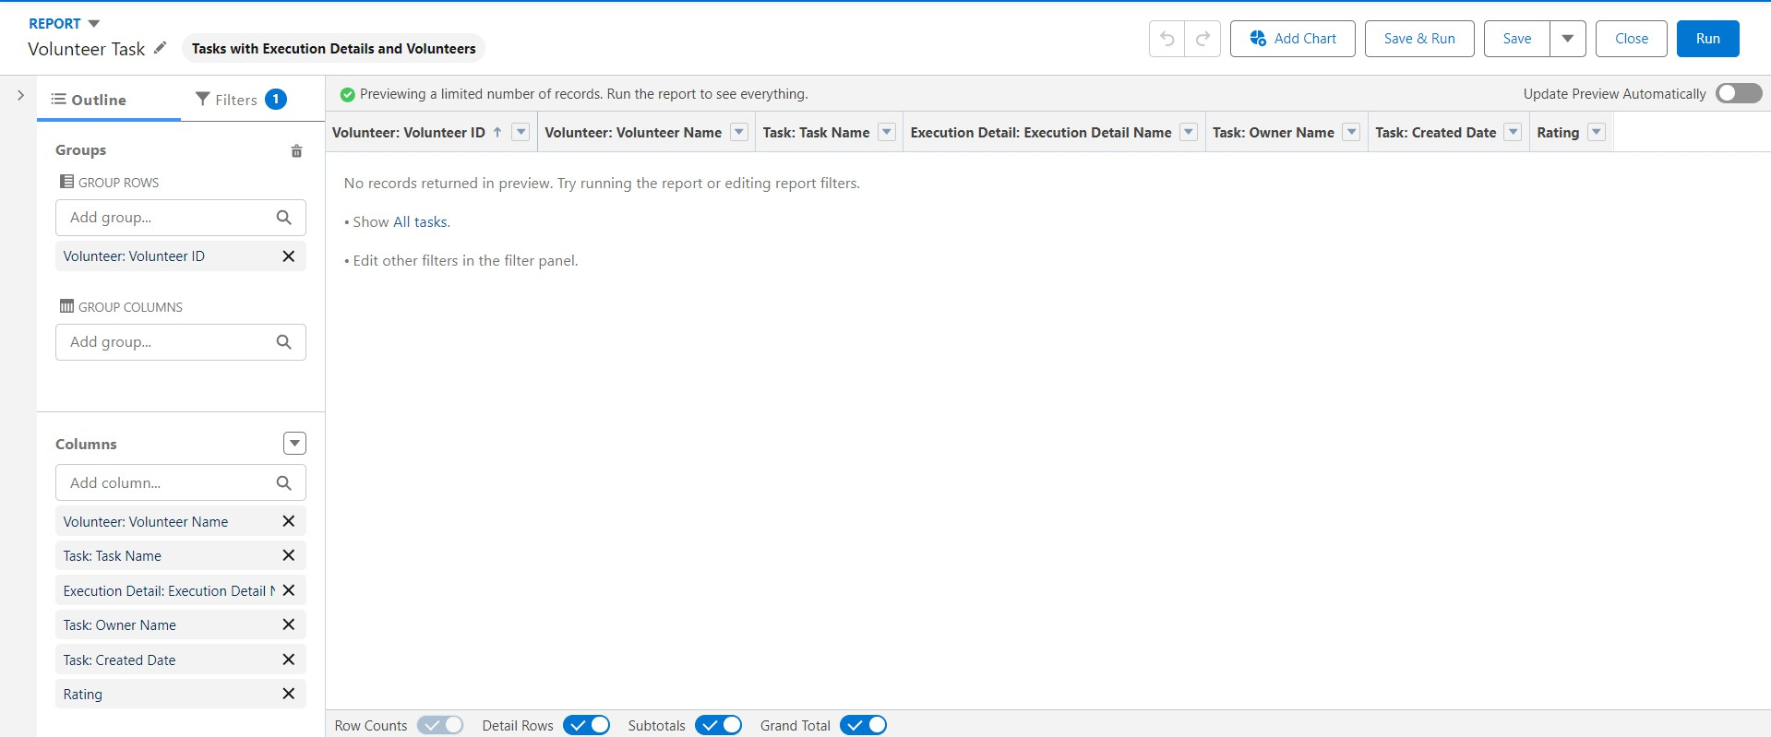

1. Dashboards

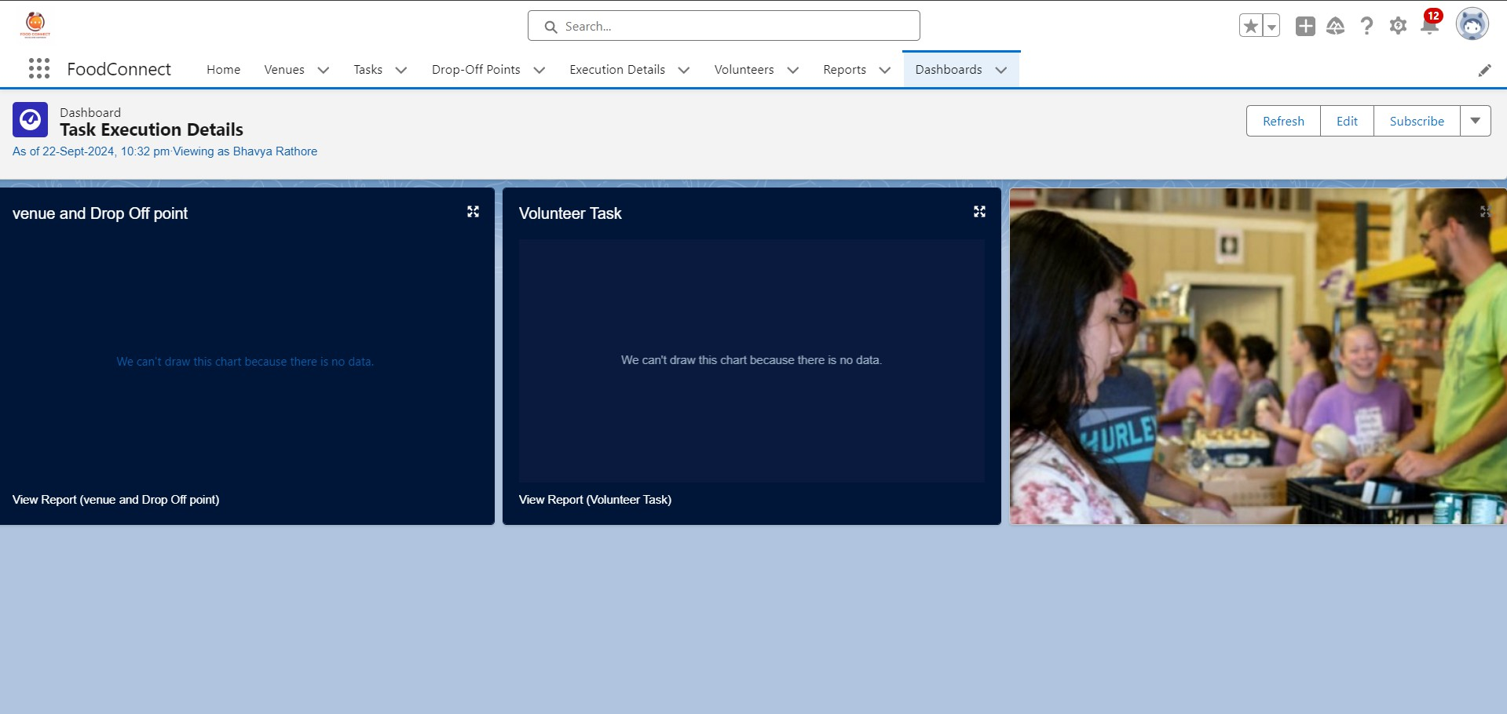

1. Creation of sharing rules

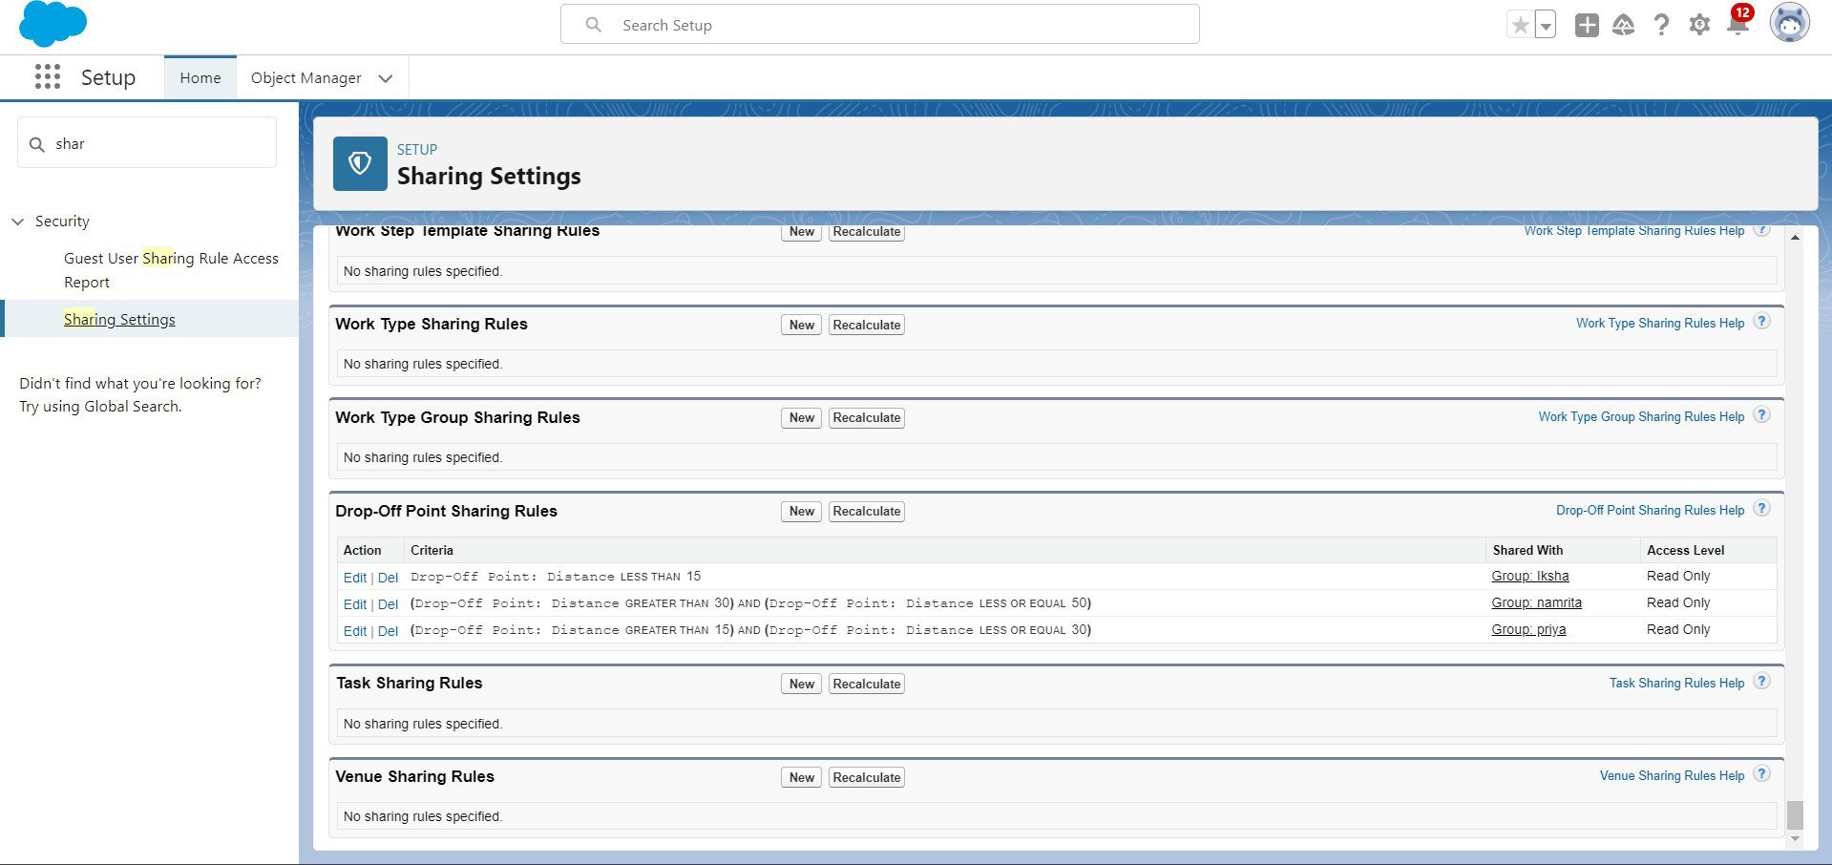

1. Creation of Home Page

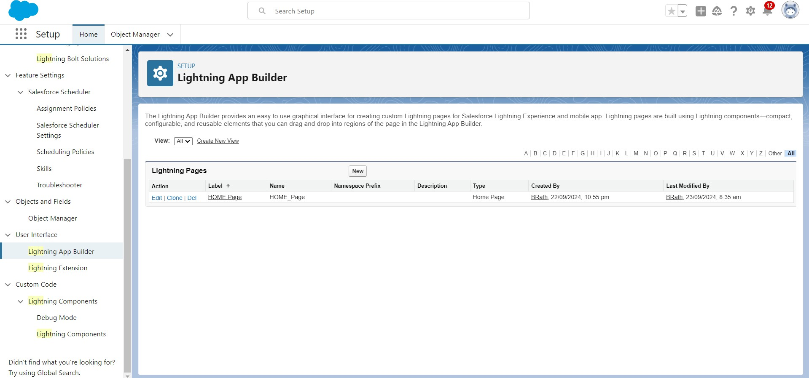

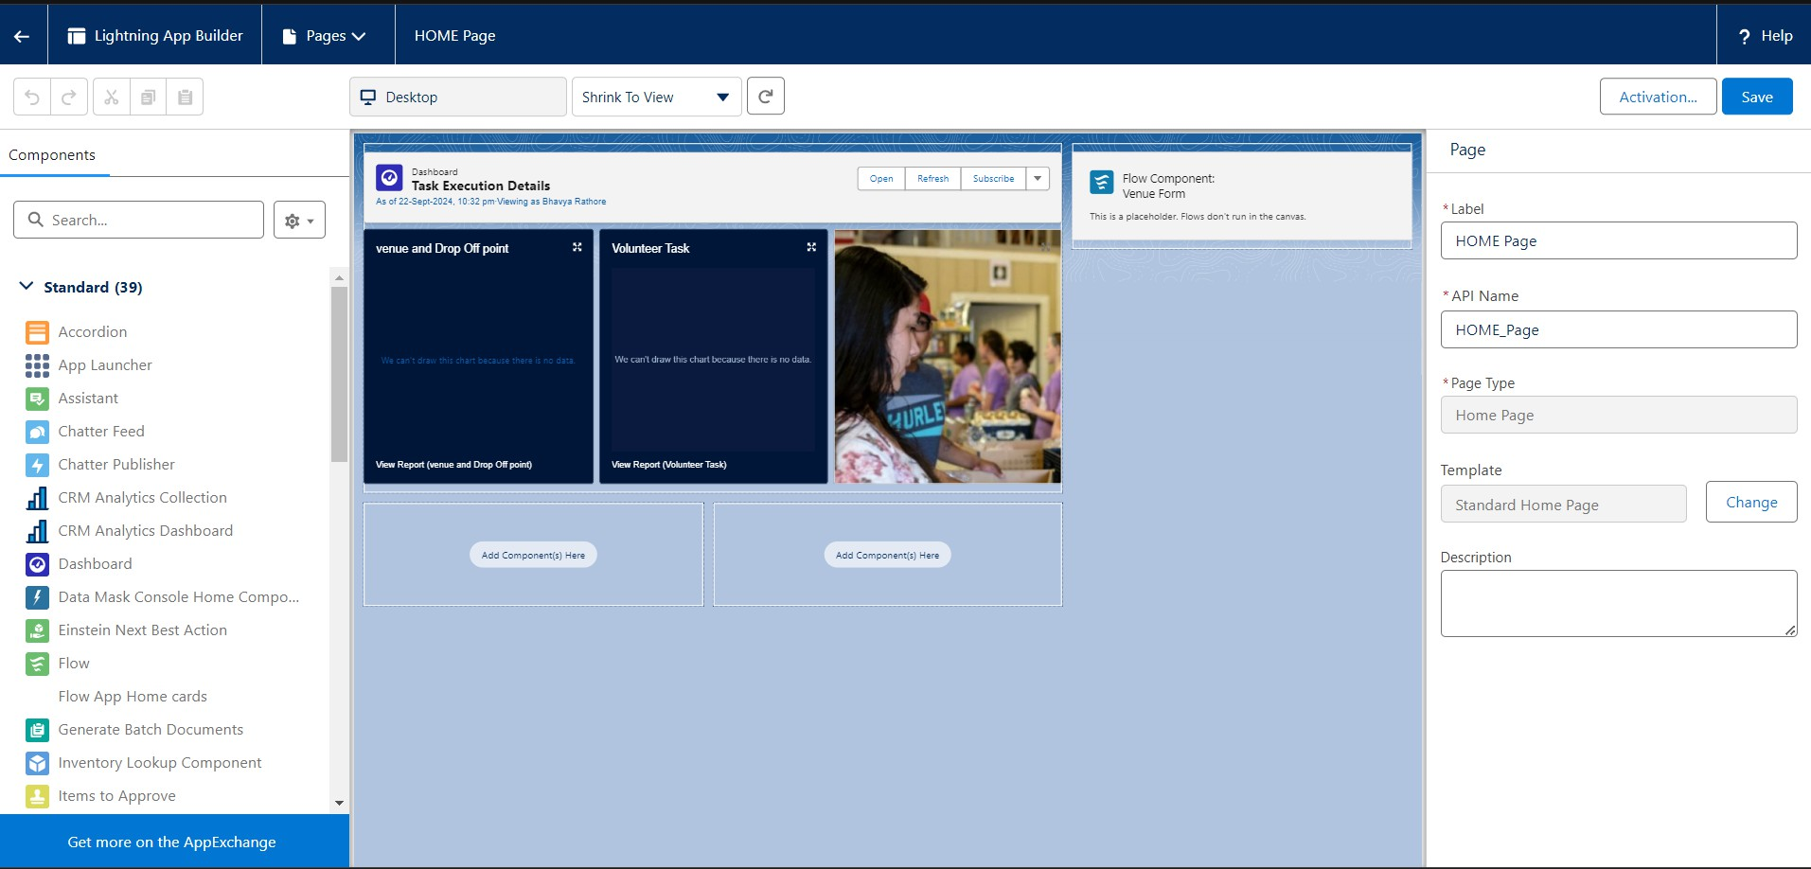

## OUTPUT SCREENSHOTS

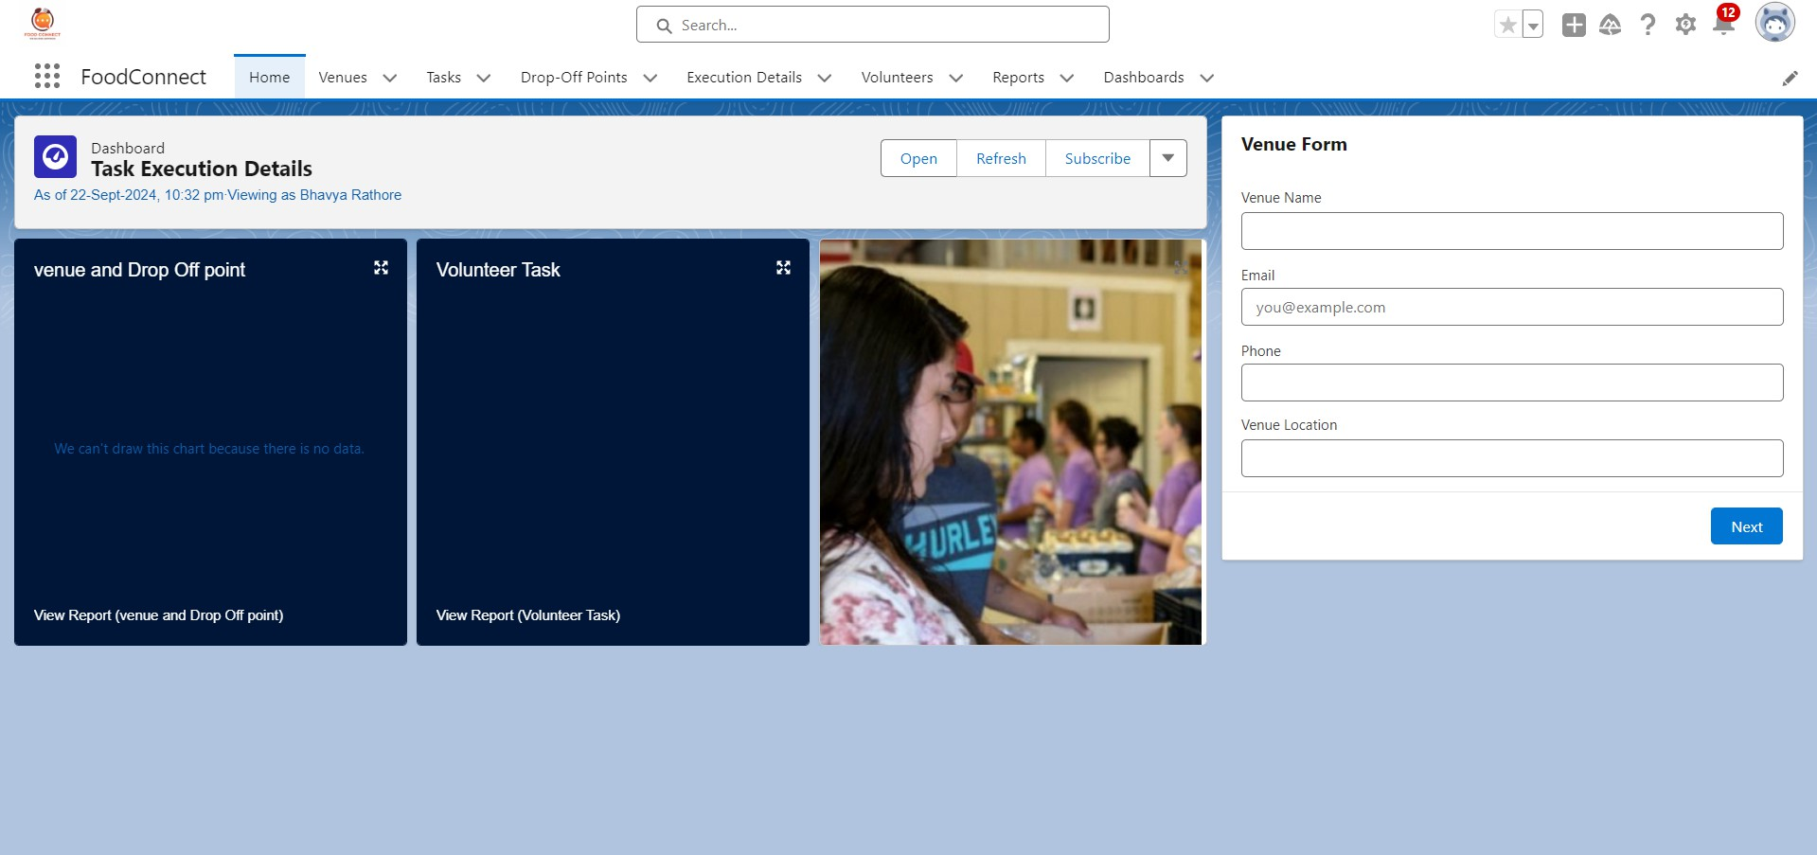

THE FINAL OUTPUT OF THE APP SHOULD LOOK LIKE THIS AFTER FOLLOWING ALL THE STEPS CORECTLY AS YOU CAN SE MY OUTPUT LOOKS CORRECT AS THE OUTPUT SHOULD BE LIKE THIS

## Vedio Demonstation

Here I am sharing my github link as well as the link where the vedio also provided in which you can see the how it looks and works...

<https://github.com/bhavyarathore11/FoodConnect-to-supply-leftover-food-to-poor>

# Conclusion

By leveraging the Salesforce platform, the project successfully established a streamlined and transparent system for managing surplus food donations. Through efficient coordination with volunteers and timely delivery to beneficiaries, the project effectively addressed food insecurity while maximizing the utilization of available resources.

Food Connect aims to bridge the gap between surplus food and those in need by

utilizing Salesforce to streamline and automate the process. The project showcases the flexibility of Salesforce’s platform in handling non-profit workflows and creating real- world impact through technology.